

A guide to converting an Excel spreadsheet to a flat file format for importing into HEPCAT

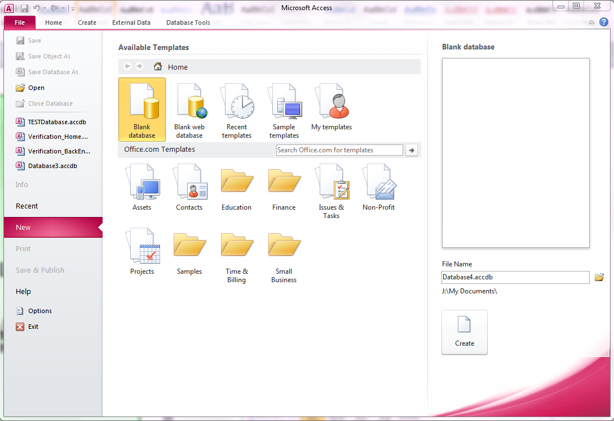

Select **Blank database…**



Click on the **Browse folder…**

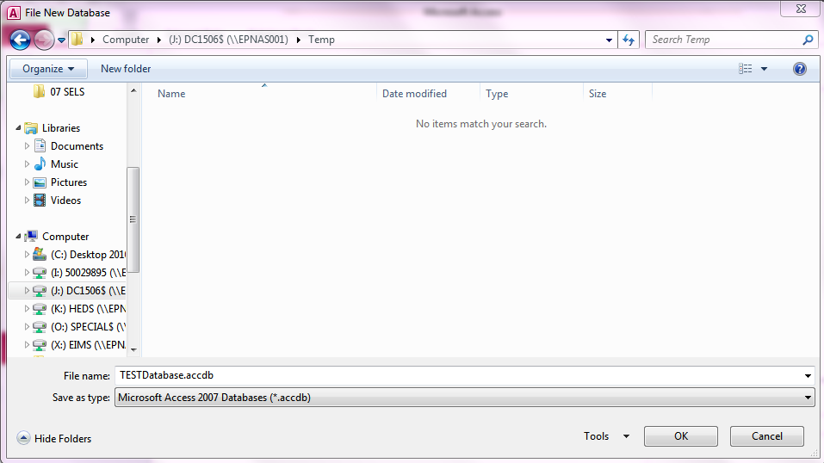

3. Click **OK**

1. Enter new file name
2. Navigate to desired folder location



Click **Create**

Click External Data
Click Excel icon

1. Click **External Data**
2. Click **Excel** icon

Access 2010 - Get External Data
Click Browse

Click **Browse**…

Go to the file location of the Excel spreadsheet that has to be imported
Select the file
Click Open

1. Click **Open**
2. Select the file
3. Go to the file location of the Excel spreadsheet that has to be imported

Get External Data - Excel Spreadsheet
With the first radio button checked, click OK

Click **OK**

Import Spreadsheet Wizard
Click Next

Click **Next**

Import Spreadsheet Wizard
Click OK

Click **OK**

Deselect First Row Contains Column Headings
Select Next twice

Select **Next** twice

Deselect **First Row Contains Column Headings**

Select No Primary key
Select Next

1. Select **Next**
2. Select **No primary key**

Import to Table Sheet1
Select Finish

Select **Finish**

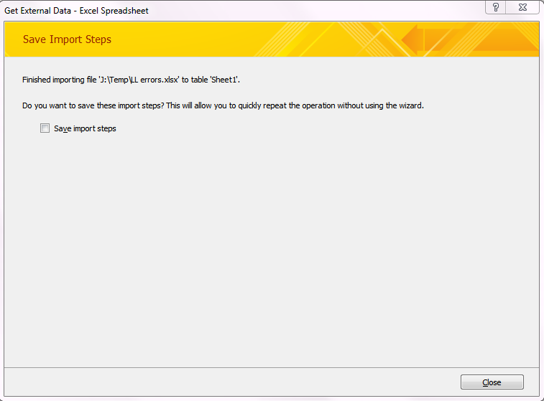

Select **Close**

Access 2010
Double click the newly created table Sheet1 to open

Double click the newly created table **Sheet1** to open

Select the Fields tab
Select the Design View button

1. Select the **Design View** button
2. Select the **Fields** tab

All Data Types must be set to Text for each field
Set the Field Size to the correct length for each Field
The field length for each field can be found in the appropriate File Specification document

The field length for each field can be found in the appropriate file specification on [HEIMSHELP](http://heimshelp.education.gov.au).

1. All **Data Types** must be set to **Text** for each field
2. Set the **Field Size** to the correct length for each **Field**

Click Save
Close this screen not the whole program
Click Yes

1. Close this screen not the whole program
2. Click **Yes**
3. Click **Save**

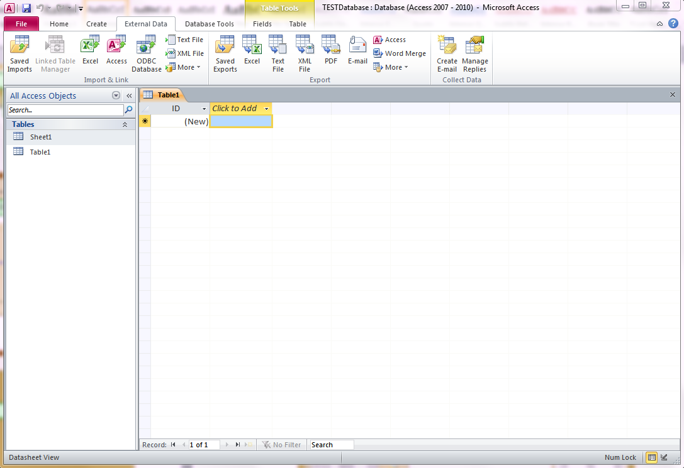

Double click table **Sheet1** to open it

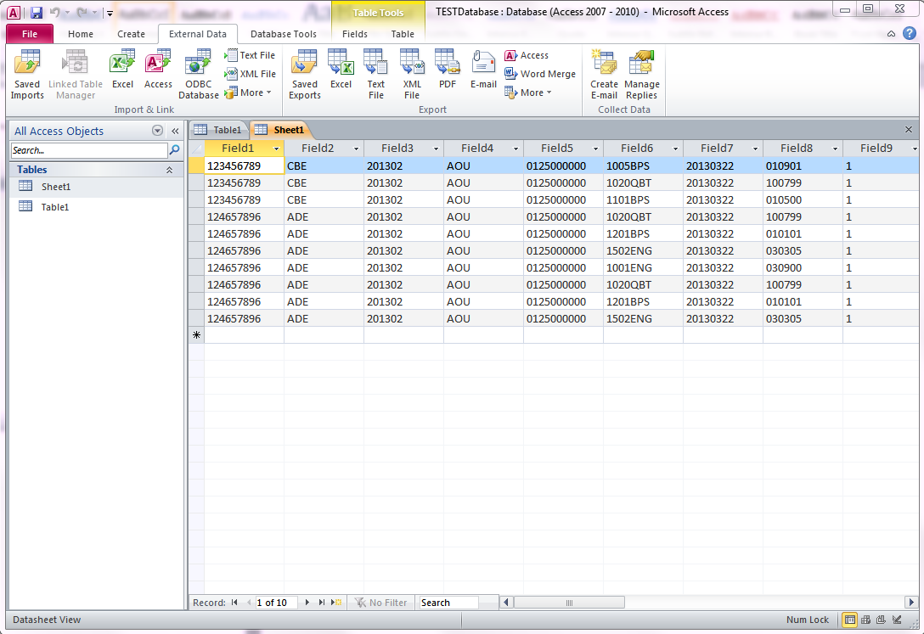

Click **Text File** in the Export ribbon tab

A text file name will be generated. This can be changed to suit requirements.
Click Browse if you want to save to a different location
Click OK

A text file name will be generated. This will need to be changed to match the HEPCAT naming convention. Please refer to the [HEPCAT Naming Convention document](http://heimshelp.education.gov.au/sites/heimshelp/support/pages/user-guides#nav) on HEIMSHELP to locate your requirements.

1. Click **Browse** if you want to save to a different location
2. Click **OK**

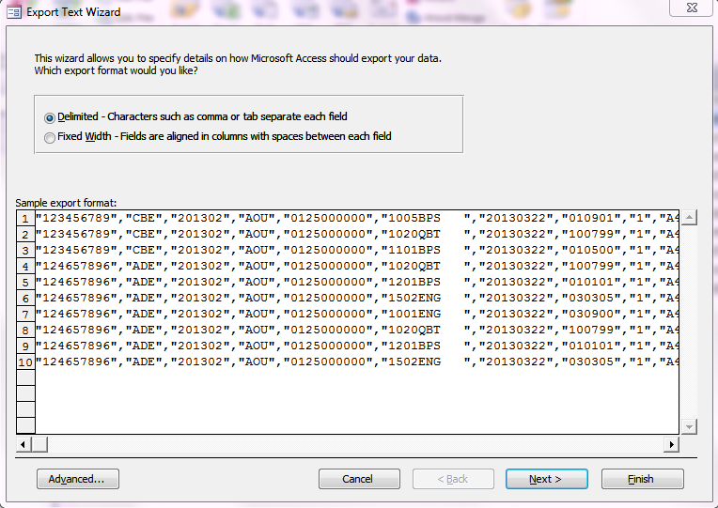

Text files with the quotes and commas will not load into HEIMS – therefore select **Fixed Width - …**

Export Text Wizard
Select Next twice+

Select **Next** twice

Export Text Wizard
Select Finish

**NOTE:** If you did not previously change the text file name you should before selecting Finish. Please refer to the [HEPCAT Naming Convention document](http://heimshelp.education.gov.au/sites/heimshelp/support/pages/user-guides#nav) on HEIMSHELP.

Select **Finish**

Export Text File
Select Close

Select **Close**

The exported file will now be located in the location you chose to export to and ready for loading into HEPCAT.